**Weka GUI**

1. Load Data

1. Preprocessing

Filtering, Remove ID

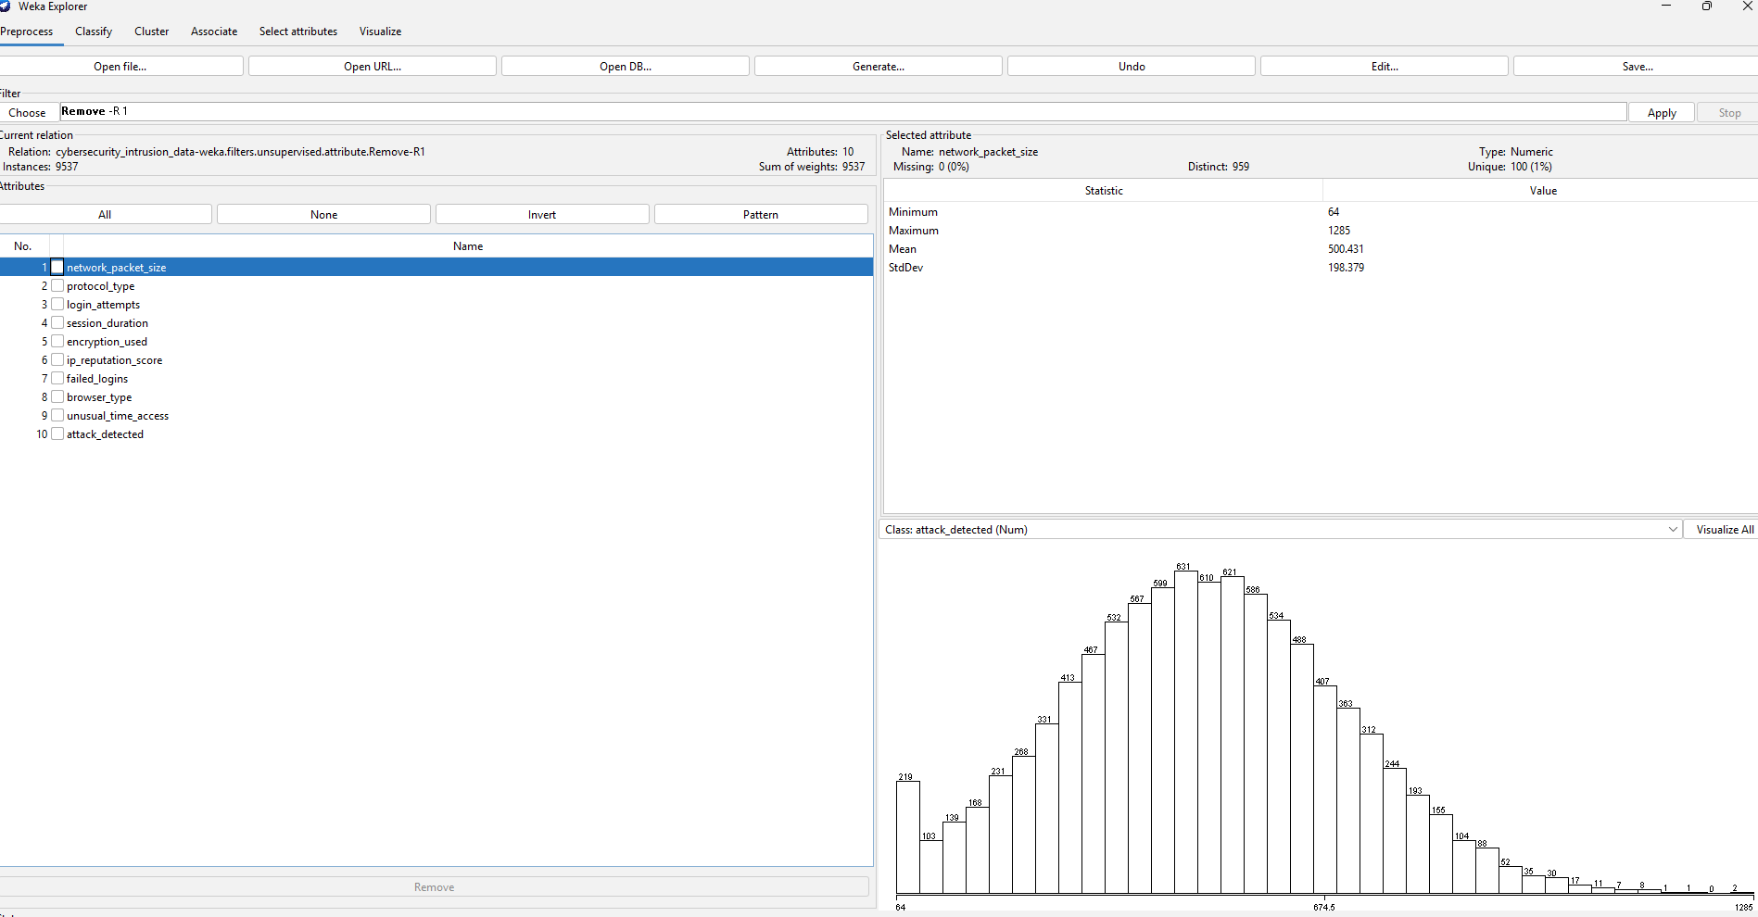

Nominal To Binary

Standerdize

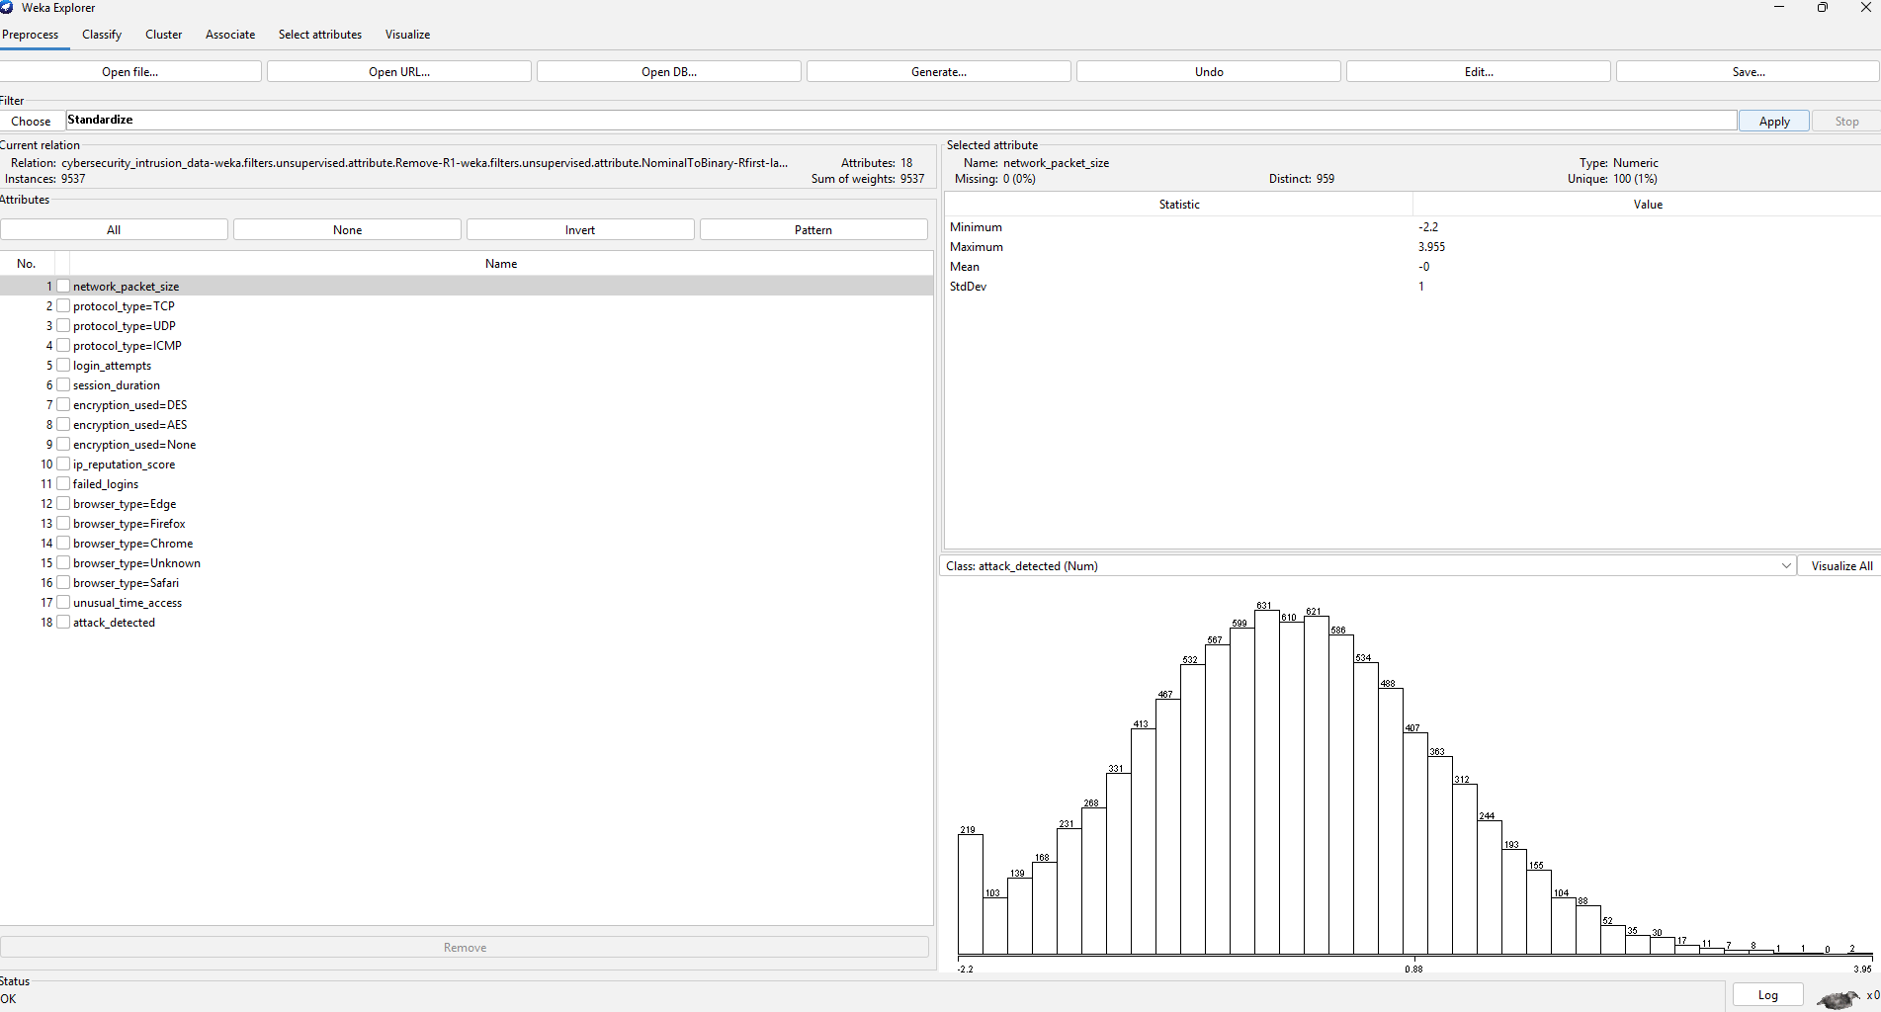

Target Attribute To Nominal

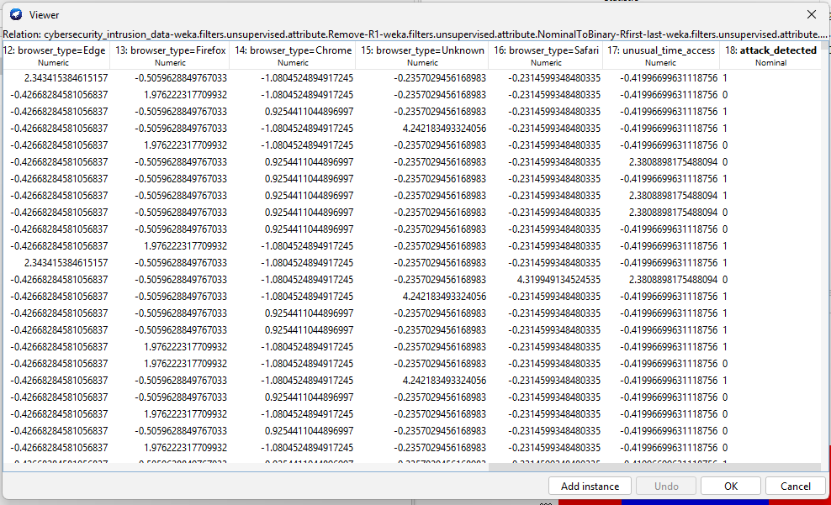

Logression results in modelling 10 fold

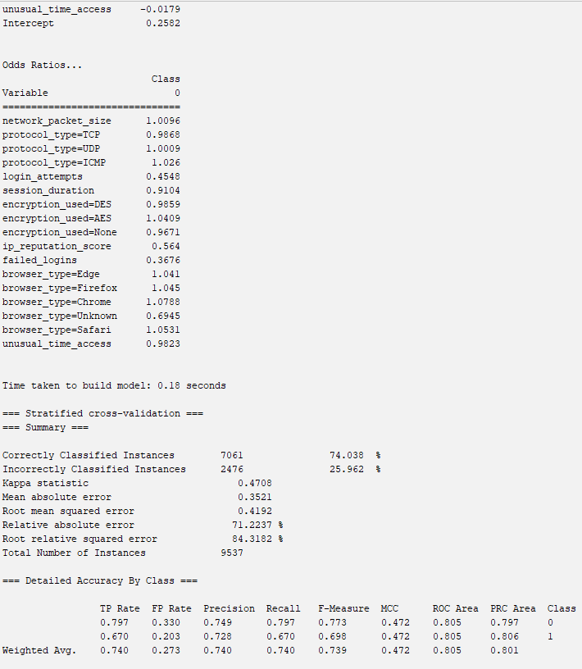

Random Forest

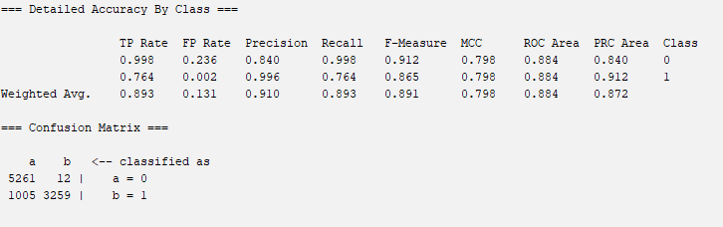

ADABOOSTM1 with J48 base classifier

